Open Enrollment Instructions
- Log into Dayforce using your Employee role (actual name of role may vary)
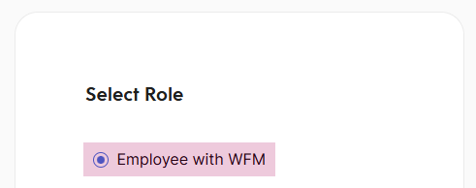
- In the top-left, open the Menu (three lines) and select the Benefits module
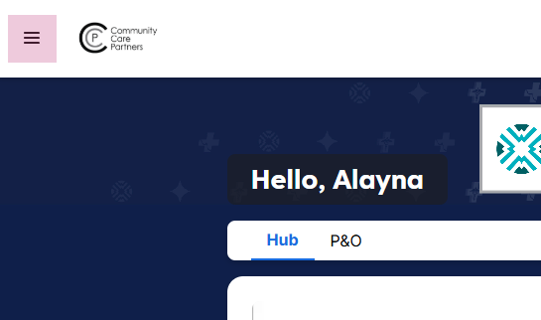
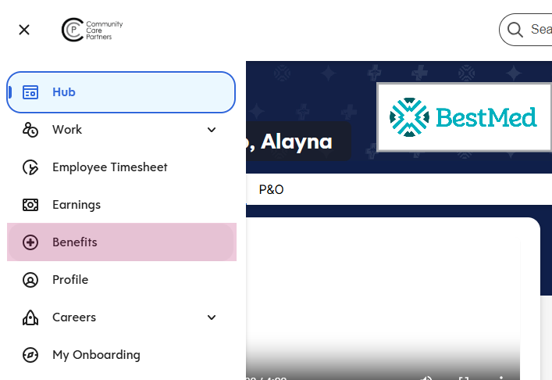

- Select Start Enrollment next to the Open Enrollment 2026 event.
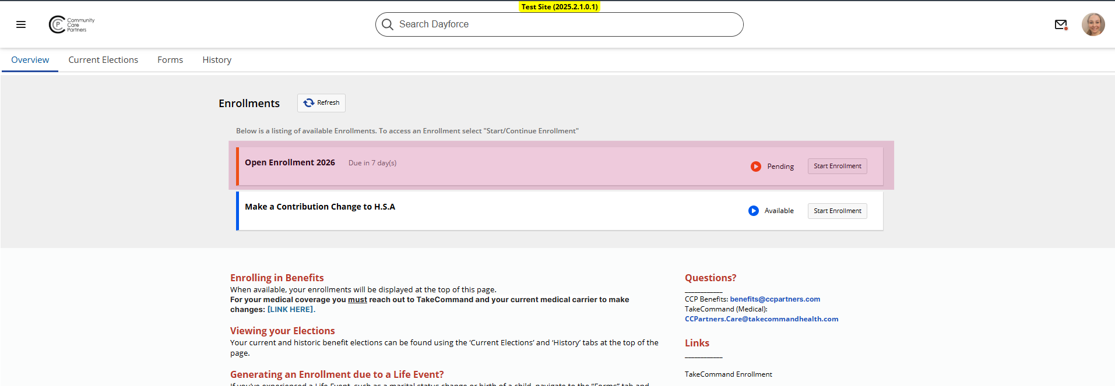
- An introduction message and the list of benefits offered is displayed immediately. To begin the enrollment, choose Start
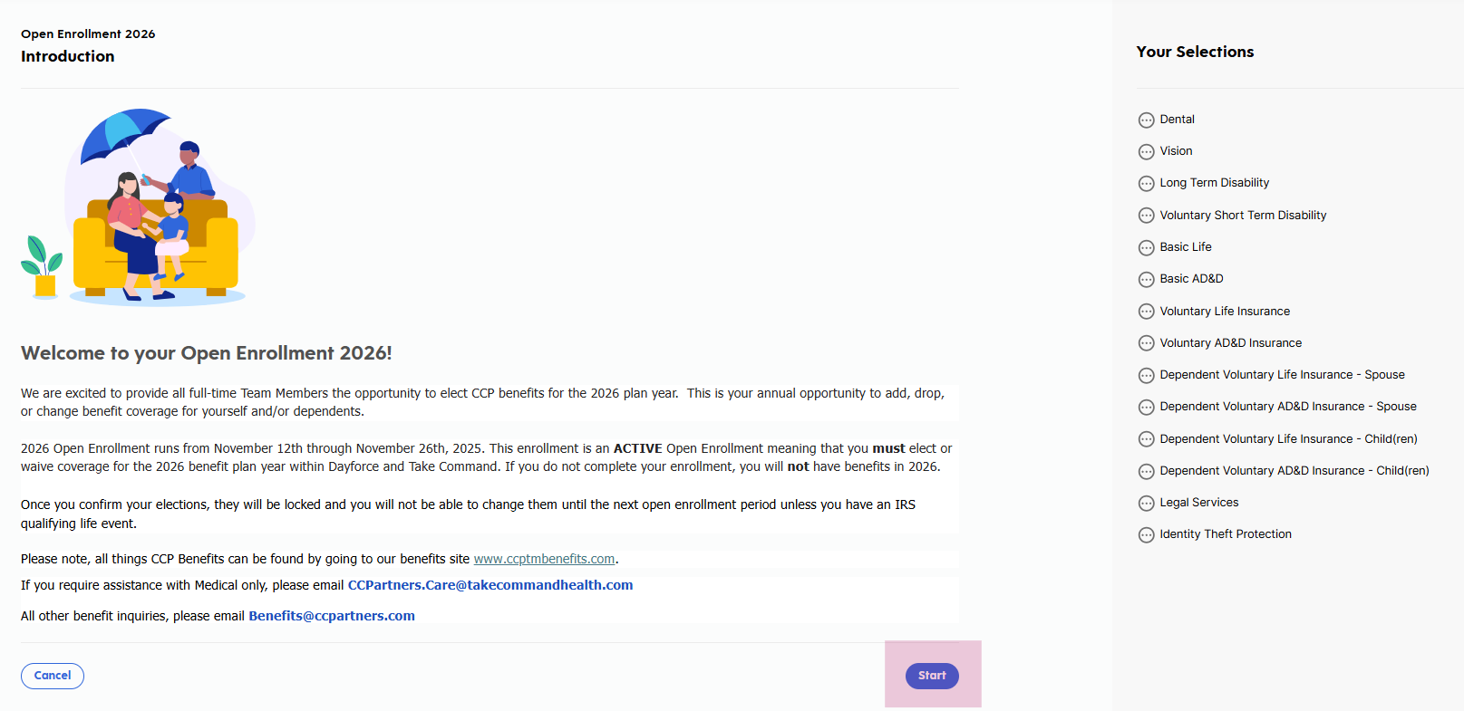
- Confirm your personal information. If any information is incorrect, follow the instructions at the top to submit the appropriate form.

- Complete all dependent information then hit continue in the bottom-right to begin making your selections:
  - Add a dependent by selecting Add Dependent then completing the requested information.
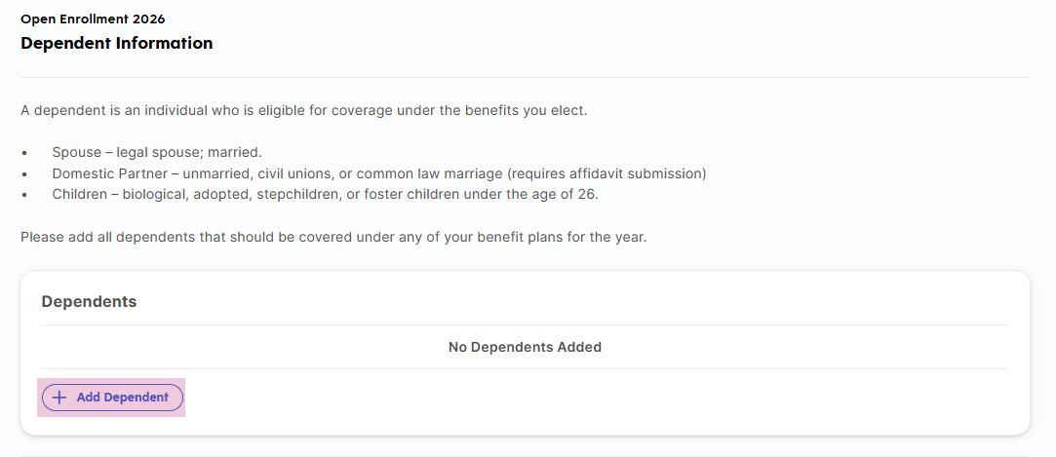
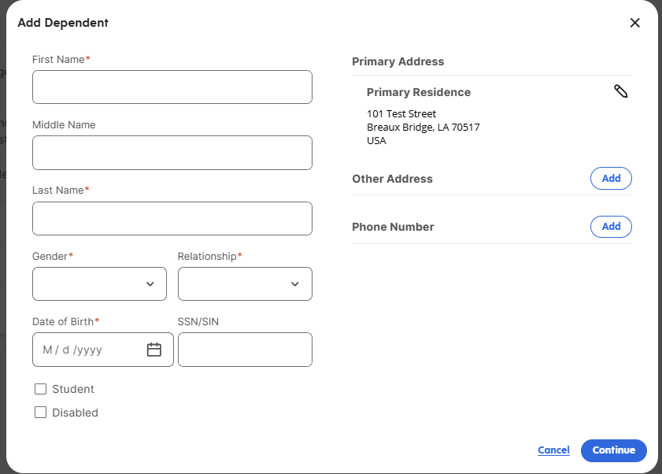
  - Update existing dependent information by selecting Edit next to an existing dependent.
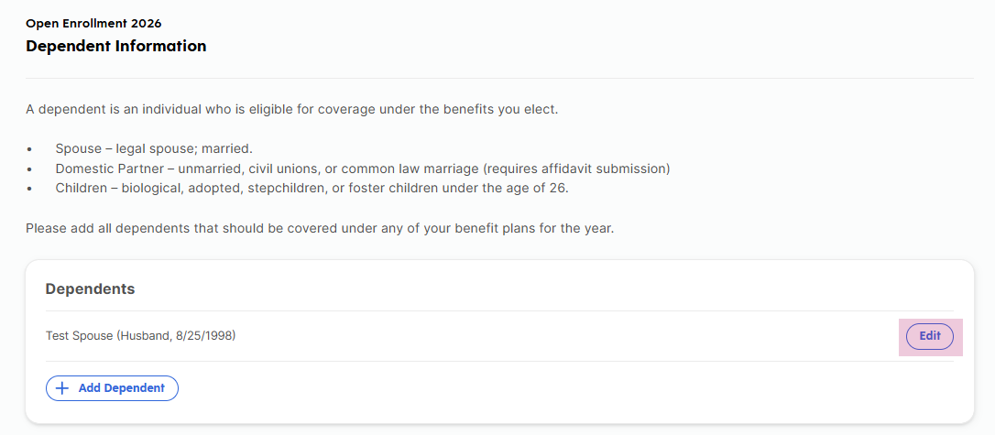
  - Remove a dependent, by choosing Edit then find the Remove button in the bottom-left of the form screen.
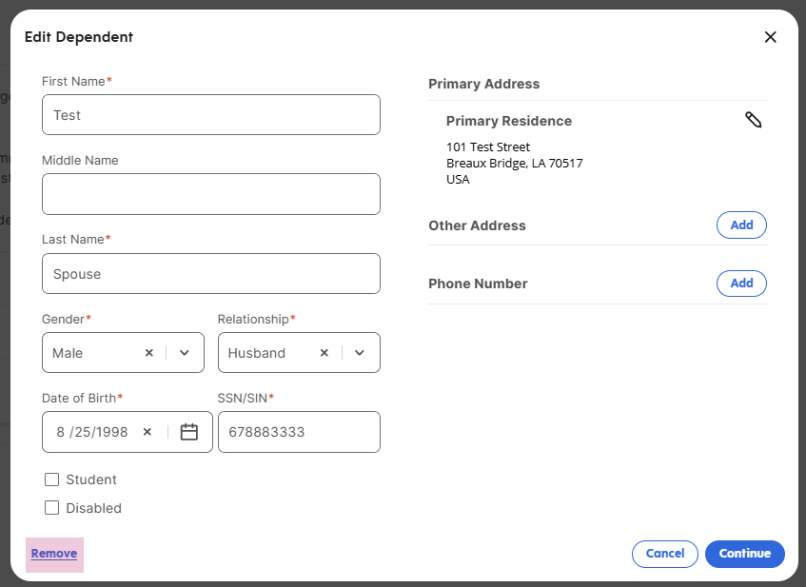
- Choose which dependents you would like covered for each applicable plan and hit Confirm to see available plan options. Continue making selections for each plan type as you move through the process.
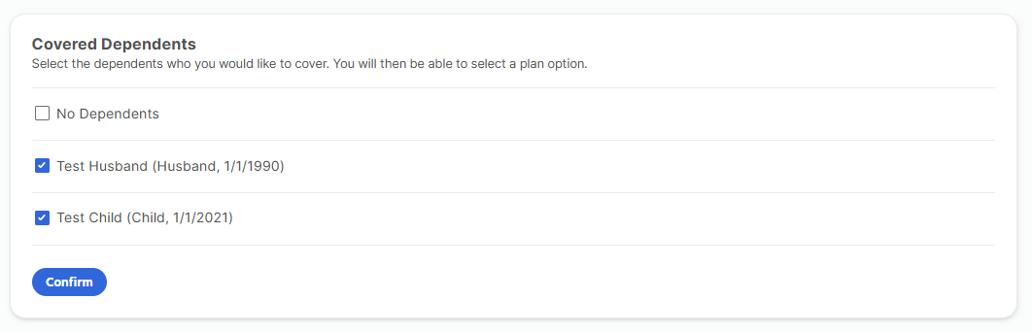
- Auto-enrolled options do not require any further action - hit Continue after reviewing.
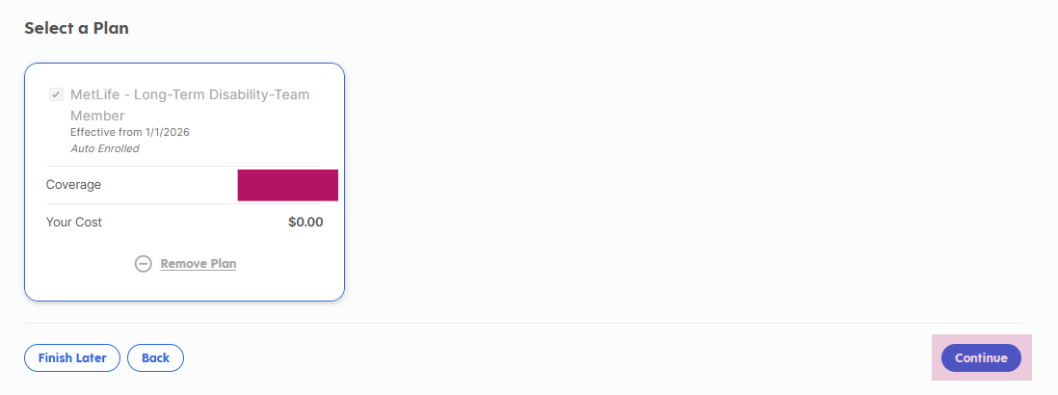

9. Plans needing a beneficiary will allow the option to add beneficiaries in addition to your existing dependents (if applicable). If a new beneficiary is not needed, Continue forward.
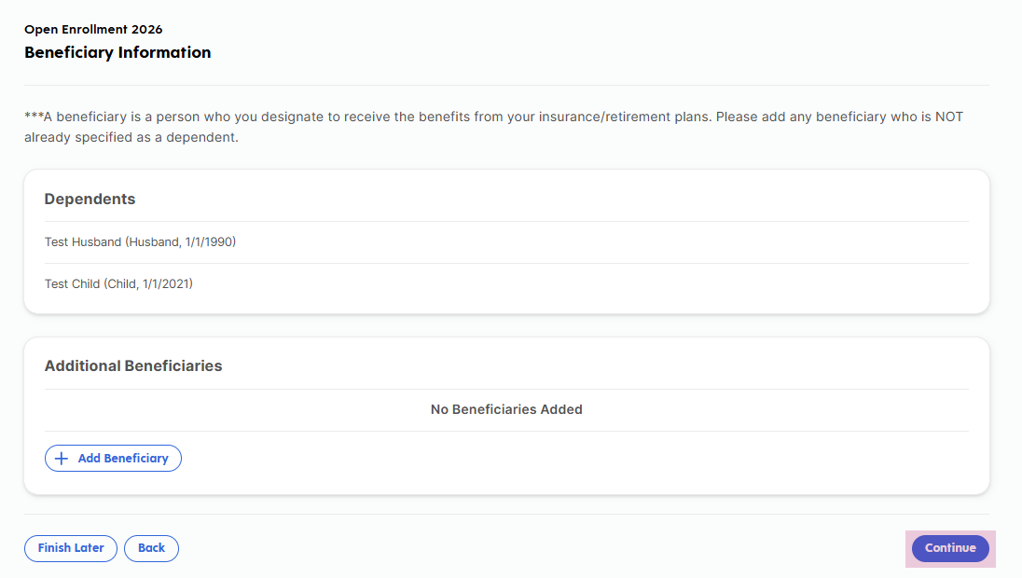
10. Once all options have been reviewed/elected/waived, a Review page will display with all details. If you are satisfied with the Review page, select the Submit button at the very bottom.
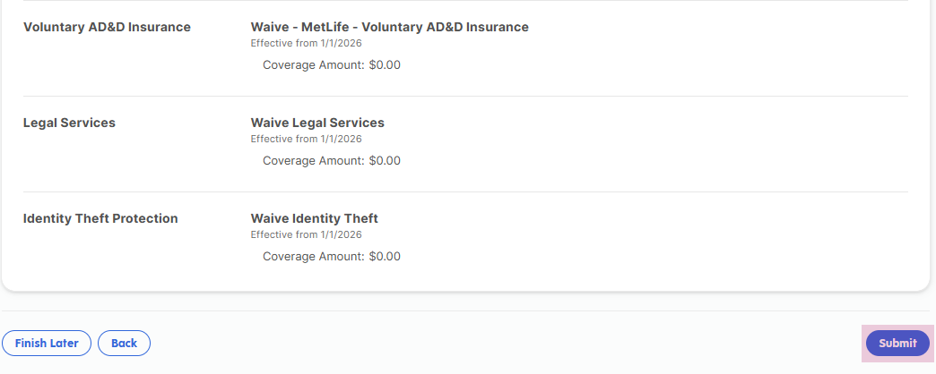

11. Select the Print button to save a copy of your enrollments summary page for your records.
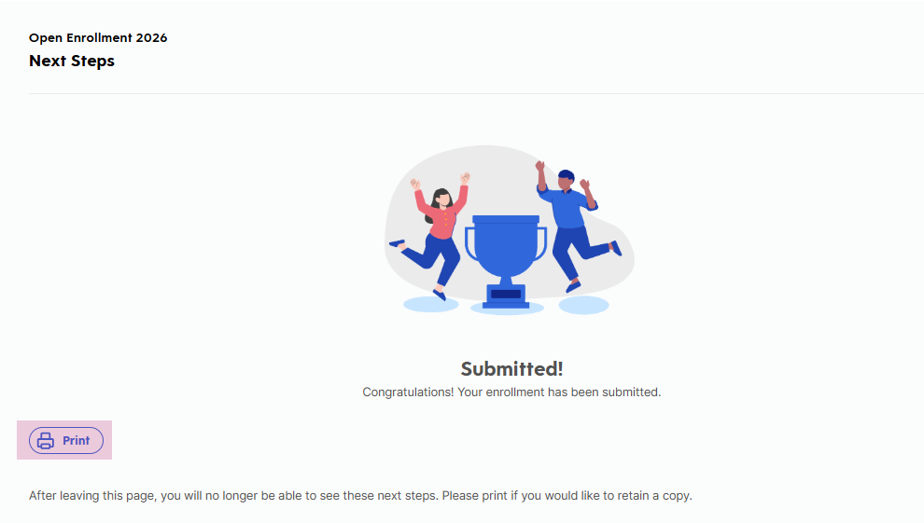
12. Continue scrolling down on the Next Steps page to find instructions regarding Medical enrollment through Take Command.
13. Navigate to the Dayforce Hub screen or completely close out of browser.

